# CHAPTER-1

# 1.1 Overview of the Organization

1. **SV Mind Logic Systems** is the leading as a web and software development company located in **Satara,Pune India**. Web Design and Development are our areas of expertise! We take pride in our work, so when we create your site it has to not only meet your requirements, but our individual high quality standards. We are serving our clients **from 2012**. We have planned, created and launched hundreds of successful websites since our inception, for many different types of **businesses around the globe.**
2. SV Mind Logic implements the latest technologies in web site design, using**Cascading Style Sheets, XHTML, HTML, XML Flash**, and implements programming languages.
3. We provides **Web application development, quality website designing at satara, Corporate profiles and presentations, creative website development** at Satara, Pune, India. Best E-commerce solutions, Application development, maintenance, re-engineering, Web hosting solutions and Search Engine Optimization, seo .
4. The company provides you a complete range of solutions facing the ever-growing client and market challenges. We give you Internet solutions that are **reliable, scalable** and highly customized for your needs using best of web technologies for your customized web development and optimization.

# 1.2 VISION

* Our vision is to develop in a constant manner and grow as a major IT service provider to become a leading performer, in providing quality Web and Software Development solutions in the competitive global marketplace.

# MISSION

* Our mission is to enhancing the business growth of our company to deliver optimal solution at reasonable price

**1.3Organization Structure**

Founder( S V Mind Logic)

Satara Branch

Nippani Branch

Branch Head Branch Head

Project Manager

ProjectManager

Marketing Head Marketing Head

Software Engineer Software Engineer

**1.4 Roles and Responsibilities**

**Role**

* Internee software engineer role.

**Responsibilities**

* To perform assigned task.
* Design the webpages.
* Design the html forms.
* Requirement research and planning.
* Problem solving by collaborate with team.
* Requirement gathering and understanding.
* Maintain Documentation of assigned task.
* Getting to know cutting edge technologies.
* Learning and coding development for the assigned task.
* Feedbacks and improvement with development and maintaining quality of work.
* Contribution to the company and the team.

### ****1.5 Advantages****

### ****1. Built for the needs of your business****

The main advantage a software solution has is that it is tailored exactly by the needs of your company. You can incorporate in such a system the tools you need to help you achieve your company’s goals. And not only that a software solution will be more efficient thanks to this aspect, but it will also keep your team focused on the features that matter rather than getting distracted by features that will not help the growth of your business.

### ****2. Great support from software developers****

The provider of your software solution will also offer you the support you need along the way of using it. They will help you with maintenance issues and any potential malfunctions that will be stipulated in your contract. Plus, you will receive the support you need in a timely manner and therefore, you won’t have to delay your work tasks if there is a defect with your software.

### ****3. Easy to use****

Software solutions that are tailored especially for your business will have only the features you need to use. This makes them more user-friendly and, in consequence, they will be more efficient as well. If you choose a software solution, you will not have to go through features that are meant for the generic market and bulk the software. Your software will be simple and functional and your entire team will be able to use it without having special IT skills.

### ****4. Integration****

Your software solution can be built in such a way that allows you to integrate it with other software solutions you might use for your company. This feature allows you to increase communication between different departments that might use different software solutions. With better communication between your team, you will notice better results and a faster growth of your business.

### ****5. Increased work efficiency****

Work efficiency is measured by the way employees follow and implement their tasks by using as little time as possible. You want high-quality work done promptly. To support this work efficiency aspect, you need software solutions that keep your team focused on their duties and reduce distractions. It is an investment in software that helps them work more smartly, rather than a harder way.

### ****6. Better planning****

The software advantage related to project management and all types of planning is crucial for enterprises focused on growth and development. You want your team to have access to all the data and tasks easily so everyone knows what they should do. Delegating tasks as a project manager is facile as well and tracking the deadlines becomes less of a struggle. Everyone will know exactly what they have to do and they can keep an eye on the overall progress of the project at all times.

### ****7. Increased productivity****

A software advantage that all companies pay attention to is [increased productivity](https://trafft.com/work-apps/). Software solutions reduce the need for repetitive tasks and eliminate delays so your team can work more productively. Features such as a database, automatic surveys, organizing information, and scheduling tasks are incorporated into the software so all your team will have to do is implement them.

### ****8. Team communication****

The communication of your team is essential for any type of project. Tasks delegation, supervision, and management are only the main aspects that depend directly on how well your team members communicate. A software solution advantage that you can’t ignore is the fact that everyone will be able to communicate all types of information and share files such as documents, videos, or audio files via one software.

### ****9. Data security****

Software solutions tend to be more secure than off-the-shelf. Such a software will only be used by your team members and members you give access to use it. Since it is not a generic software, the risks of having it hacked are a lot smaller. Plus, if you have any security concerns regarding your sensitive data, you can always talk to your software creator about them, ask to run some [security tests](https://sumatosoft.com/blog/software-security-principles) and enhance the data protection. Finally, you’ll find the optimum solution to your enterprise’s needs.

### ****10. Better customer service****

Customer service is one of the main focus points for all enterprises. Using the right software solution for your business will help you build a better relationship with your clients and address their potential issues more efficiently. You will have the option to create automatic questions so your customers will be directed to the right department that can help them according to the problem they have. Software solutions also help you stay on top of the information your customers might need to use your products or access your services in the best way.

### ****11. Increased scalability****

Software solutions come with superior scalability to any other software solutions. You can develop the way you use the software by adding more users and data. These solutions also allow you to access new features after potential upgrades that will support the growth of your enterprise. Ultimately, you can look at your Software solution as software that will help your company grow through its scalability. You can access different scalability levels of the software you use via your subscription, with no additional effort.

### ****12. Sales lead****

Enterprises of all types rely on sales. Be it product or service sales, you can’t reach the success you aim for without them. All software solutions have the advantage of increasing your sales, directly or indirectly.

## **1.6 Features**

## **1. Expertise and Experience**

A [leading software development company in the USA](https://techreviewer.co/top-software-development-companies-in-usa) should have a team of highly skilled professionals with expertise in various technologies and programming languages. They should have a track record of successfully delivering projects across different industries. Their experience allows them to understand your specific requirements and provide tailored solutions.

## **2. Comprehensive Service Offerings**

A top software development company should offer various services to cater to different client needs. These services may include software development, web development, mobile app development, quality assurance, cloud solutions, UI/UX design, and more. By providing comprehensive services, they can handle all aspects of your project, ensuring seamless integration and a smooth development process.

## **3. Agile Development Methodology**

Agile development has become the industry standard due to its flexibility and efficiency. A leading software development company should follow Agile methodologies such as Scrum or Kanban. They should be able to adapt quickly to changing requirements, deliver frequent iterations, and involve the client throughout the development process. Agile development ensures transparency, collaboration, and [faster time-to-market](https://www.tcgen.com/time-to-market/).

## **4. Client-Centric Approach**

A client-centric approach is vital for a leading software development company. They should prioritize understanding your business goals, target audience, and project requirements. They should actively involve you in the decision-making process, provide regular updates, and seek feedback at every stage. A client-centric approach ensures that the final product aligns with your vision and meets your expectations.

## **5. Strong Communication Channels**

Effective communication is the key to a successful software development project. A leading company should have strong communication channels in place to facilitate smooth and timely communication. They should be responsive to your queries, provide regular progress reports, and have clear lines of communication within their team.

## **6. Emphasis on Quality Assurance**

Quality assurance is crucial for any software development project. A leading company should have a dedicated team of quality assurance professionals who ensure that the software meets the highest standards. They should conduct rigorous testing, identify and fix any bugs or issues, and ensure the software is secure and reliable. Robust quality assurance practices ensure that the final product functions flawlessly.

## **7. Proven Track Record of Success**

When choosing a software development company, look for one with a proven track record of success. They should be able to provide references, case studies, or testimonials from satisfied clients. Their portfolio should demonstrate their ability to deliver high-quality projects on time and within budget. A company with a solid track record gives you confidence in their capabilities and increases the likelihood of project success.

## **8. Scalability and Flexibility**

A leading software development company should be able to scale their resources and accommodate your changing needs. They should have the capability to handle projects of different sizes and complexity. Whether you need a small-scale application or a large enterprise solution, they should have the scalability and flexibility to meet your requirements. Scalability ensures that the company can grow with your business and adapt to future challenges.

**1.7 Internship Roadmap**

1. Fundamental concept.
2. Hands or practical
3. Industrial use case study
4. Live project implementation
5. Dual certificate

**1.8 Overview of Full Stack Development**

**1. Frontend Development:** This involves creating the user interface and user experience of web applications. Key technologies and skills include:

* **HTML (HyperText Markup Language):** The standard markup language for creating web pages and web applications.
* **CSS (Cascading Style Sheets):** Used to style the appearance of HTML elements on web pages.
* **JavaScript:** A programming language that enables dynamic and interactive features on web pages. Frameworks and libraries such as React, Angular, and Vue.js are commonly used for frontend development.
* **Responsive Design:** Ensuring that web applications are optimized for various screen sizes and devices.

**2. Backend Development:** This involves building the server-side logic and database interactions of web applications. Key technologies and skills include:

* **Server-Side Languages**: Common languages used for backend development include JavaScript (Node.js), Python (Django, Flask), Ruby (Ruby on Rails), Java (Spring Boot), and PHP (Laravel).
* **Databases:** Understanding of relational databases (e.g., MySQL, PostgreSQL) and NoSQL databases (e.g., MongoDB) for storing and retrieving data.
* **APIs (Application Programming Interfaces):** Building and consuming APIs to enable communication between the frontend and backend components of web applications.
* **Authentication and Authorization:** Implementing user authentication and authorization mechanisms to secure web applications.

**3. Version Control:** Proficiency in using version control systems like Git for managing codebase changes and collaboration with other developers.

**4. DevOps:** Familiarity with DevOps practices, including continuous integration (CI) and continuous delivery (CD), to automate the deployment and testing processes of web applications.

**5. Knowledge of Web Servers and Hosting Environments:** Understanding of web servers (e.g., Apache, Nginx) and cloud platforms (e.g., AWS, Google Cloud Platform, Microsoft Azure) for hosting and deploying web applications.

**6. Problem-Solving and Troubleshooting Skills:** Ability to identify and resolve issues in both frontend and backend components of web applications.

**7. Soft Skills:** Effective communication, teamwork, and time management skills are essential for collaborating with other developers, designers, and stakeholders in the development process.

### 

.

**1.9 Products Performance**

* **Hospital Management**

This is a budget ERP package for Hospitals/clinics to automate the day to day operations of the hospital/clinic & patients.

* **Hotel Lodging**

This application is designed for hotel lodging to be able to make online bookings for their hotel & overall management of the hotel.

* **Ecommerce Store**

The benefits of e-commerce include its around-the-clock availability, the speed of access, a wider selection of goods and services, accessibility, and international reach.

* **MLM Solution**

Our company offers a complete set-up of MLM product that are developed for fulfilling the expectations of multi-level marketing.

* **School & Web ERP**

Web ERP is a complete web based accounting and business management system that requires only a web-browser and pdf.

**1.10 Marketing Performance**

**1.Lead Generation:**The number of leads generated through marketing efforts such as website visits, content downloads, webinar registrations, etc. Tracking the source of leads can help determine which marketing channels are most effective.

**2. Website Traffic:** Monitoring website traffic metrics such as unique visitors, page views, bounce rate, and time spent on site can provide insights into the effectiveness of online marketing efforts and the attractiveness of the company's website.

**3.Conversion Rate:** This measures the percentage of leads that convert into customers. Analyzing conversion rates at different stages of the sales funnel can help identify areas for improvement in the marketing and sales processes.

**4. Customer Acquisition Cost (CAC):**Calculating the cost associated with acquiring a new customer can help determine the efficiency of marketing campaigns and budget allocation.

**5.Return on Investment (ROI):** Assessing the return on investment for each marketing campaign or channel can help determine which efforts are driving the most revenue and profitability for the company.

**6. Customer Retention and Lifetime Value (LTV):**Retaining existing customers and maximizing their lifetime value is crucial for long-term business success. Monitoring customer retention rates and LTV can indicate the effectiveness of marketing efforts in building customer loyalty.

**7. Brand Awareness and Reputation:** Tracking metrics such as brand mentions, social media engagement, and online reviews can provide insights into the company's brand awareness and reputation within the industry.

**8 .Competitive Benchmarking:**Comparing the company's marketing performance metrics against competitors can help identify strengths, weaknesses, and opportunities for improvement.

**9. Marketing Channels Performance:** Analyzing the performance of different marketing channels (e.g., social media, email marketing, SEO, paid advertising) can help optimize resource allocation and marketing strategies.

**10. Customer Feedback and Satisfaction:** Gathering feedback from customers through surveys or reviews can provide valuable insights into customer satisfaction levels and areas for improvement in the company's products and services.

**1.11 Conclusion**

A software development company is the facilitator enabling business enterprises to implement software products that address their operational needs and help improve sales and revenue.

**CHAPTER-2**

**2.1 ABSTRACT**

The Car Rental Project is an innovative web-based application developed to transform the traditional process of renting cars into a seamless and efficient online experience. In today's fast-paced world, convenience and accessibility are paramount, and the project aims to address these needs by providing users with a comprehensive platform for renting vehicles. This abstract provides an overview of the Car Rental Project, outlining its objectives, features, technologies, and potential impact on the car rental industry

The car rental industry has witnessed significant transformations with the advent of digital platforms, offering customers convenience, flexibility, and a seamless booking experience. This case study explores the development and implementation of a digital car rental platform aimed at revolutionizing the traditional car rental process.

The project encompasses a comprehensive analysis of market trends, customer preferences, and technological advancements to design a user-centric platform. Key features include user registration and authentication, intuitive search and booking functionalities, secure payment processing, and an administrative dashboard for managing fleet inventory and user accounts.

# 2.2 INTRODUCTION

The Car Rental Project is a sophisticated web application developed to streamline the process of renting cars online. It offers a seamless user experience by combining cutting-edge frontend technologies with robust backend functionalities. This report delves into the intricacies of the project, showcasing its architecture, features, and technologies employed.

The Car Rental Project represents a significant advancement in the realm of online car rental services, aiming to revolutionize the way individuals rent vehicles. In today's fast-paced world, convenience and efficiency are paramount, and the project endeavors to provide just that. This introduction provides a comprehensive overview of the Car Rental Project, highlighting its objectives, scope, and significance.

The Car Rental Management System is a comprehensive software solution designed to streamline the operations of car rental businesses, enhancing efficiency, customer experience, and overall profitability. From managing fleet inventory to handling reservations and automating billing processes, this system serves as the backbone for the seamless functioning of rental operations.

Efficiently manage a diverse fleet of vehicles, including cars, SUVs, vans, and luxury vehicles. Track vehicle availability, maintenance schedules, and performance metrics to ensure optimal utilization and customer satisfaction.

Facilitate easy and hassle-free booking processes for customers. Provide an intuitive interface for customers to browse available vehicles, select rental options, and make reservations online or through dedicated mobile application

# 2.3 OBJECTIVES

At its core, the Car Rental Project aims to simplify and streamline the process of renting cars online. Traditional methods of renting vehicles often involve cumbersome paperwork, long wait times, and limited availability. By leveraging cutting-edge technologies and innovative design principles, the project seeks to address these pain points and provide users with a seamless and intuitive platform for renting cars.

**The primary objectives of the Car Rental Project include:**

1. Enhancing User Experience: By offering a user-friendly interface and intuitive navigation, the project aims to provide users with a hassle-free renting experience.
2. Optimizing Efficiency: Through automation and optimization of backend processes, the project strives to reduce turnaround times and improve overall efficiency.
3. Ensuring Reliability: By implementing robust security measures and reliable infrastructure, the project seeks to instill confidence in users and foster long-term trust and loyalty.
4. Facilitating Administration: The project also caters to administrators, providing them with tools and functionalities to oversee system operations, manage inventory, and monitor transactions effectively.

**2.4 Methodology**

The methodology adopted for the development of the Car Rental Project is crucial for ensuring the successful implementation of the system while meeting the project objectives efficiently. The following methodology outlines the systematic approach used in the development process:

1. **Requirements Analysis:**

•Conduct thorough analysis and gather requirements from stakeholders, including users and administrators.

•Define functional and non-functional requirements, considering usability, performance, security, and scalability.

•Create use cases, user stories, and personas to understand user interactions and system functionalities comprehensively.

2**. Design Phase**:

•Develop a system architecture based on the client-server model, utilizing frontend technologies (HTML5, CSS, JavaScript) and backend technologies (PHP, MySQL).

•Design database schema for storing user data, car listings, reservations, and administrative information, ensuring data integrity and efficient querying.

•Create wireframes and mockups to visualize user interfaces, focusing on intuitive navigation and user experience.

3. **Development:**

•Implement frontend components using HTML5 for structure, CSS (Bootstrap) for styling, and JavaScript (jQuery, AJAX) for dynamic interactions.

•Develop backend functionalities using PHP 5.5, including user authentication, car listing management, reservation handling, and administrative tools.

•Integrate frontend and backend components to ensure seamless communication and functionality across the system.

•Implement security measures, such as data encryption, input validation, and access controls, to safeguard user information and system integrity.

**4. Testing:**

•Conduct rigorous testing of the system to identify and rectify any defects or inconsistencies.

•Perform functional testing to ensure that all features work as intended and meet the specified requirements.

•Carry out usability testing to evaluate user interfaces and interactions, gathering feedback from potential users for further improvements.

•Perform performance testing to assess system responsiveness, scalability, and resource utilization under various loads and conditions.

•Implement automated testing tools and frameworks to streamline the testing process and improve efficiency.

5. **Deployment:**

•Prepare the system for deployment to a production environment, including server setup, database configuration, and application deployment.

•Perform thorough testing in the production environment to ensure compatibility and stability.

•Monitor system performance and user feedback post-deployment, addressing any issues or concerns promptly.

•Provide user training and support to ensure a smooth transition to the new system and maximize user adoption.

**6. Maintenance and Iteration:**

•Implement a maintenance plan to address ongoing updates, bug fixes, and enhancements based on user feedback and changing requirements.

•Regularly monitor system performance and security, applying patches and updates as needed to maintain optimal functionality and protect against vulnerabilities.

•Continuously gather user feedback and analytics data to identify areas for improvement and prioritize future iterations and enhancements accordingly.

By following this systematic methodology, the Car Rental Project can be developed and deployed effectively, ensuring a high-quality, user-friendly, and reliable system that meets the needs of users and administrators alike.

**Back-End Technology Methodology:**

1. **Requirement Analysis:**

• Identify the core functionalities required for the back-end, such as user authentication, database management, reservation handling, and administrative tasks.

• Determine the data structures and relationships needed to support these functionalities.

2**.Technology Selection**:

• Choose appropriate back-end technologies based on project requirements, scalability needs, and team expertise.

• Consider factors such as programming language (e.g., PHP), database management system (e.g., MySQL), and frameworks (if applicable).

1. **Database Design:**

• Design a database schema that efficiently stores and retrieves data related to users, cars, reservations, and administrative tasks.

Normalize the database structure to minimize redundancy and ensure data integrity.

1. **Development:**

• Implement back-end functionalities according to the defined requirements and database schema.

• Follow best practices for coding, including modularization, error handling, and security measures (e.g., input validation, SQL injection prevention).

1. **Testing:**

• Conduct thorough testing of back-end functionalities to ensure they perform as expected and handle various scenarios gracefully.

• Perform unit testing, integration testing, and system testing to validate functionality, data integrity, and performance.

1. **Deployment:**

• Deploy the back-end system to a production environment, ensuring compatibility with server configurations and security measures.

• Monitor system performance and address any issues that arise during deployment.

1. **Maintenance and Optimization:**

• Implement a maintenance plan for ongoing updates, bug fixes, and optimizations.

•Continuously monitor and optimize database performance, query efficiency, and server resources to ensure scalability and reliability.

**Front-End Technology Methodology:**

1. **Requirement Analysis:**

• Identify user interface requirements, including navigation flows, information architecture, and design preferences.

• Consider usability, accessibility, and responsiveness across different devices and screen sizes.

1. **Technology Selection**:

• Choose appropriate front-end technologies based on design requirements, browser compatibility, and development efficiency.

• Consider HTML5 for structure, CSS (Bootstrap) for styling, and JavaScript libraries (e.g., jQuery) for interactivity.

1. **Design:**

• Create wireframes and mockups to visualize the user interface and gather feedback from stakeholders.

• Design user interfaces that are intuitive, visually appealing, and consistent with modern design trends.

1. **Development:**

• Implement front-end components using HTML5, CSS (Bootstrap), and JavaScript (jQuery) based on the approved designs.

• Ensure cross-browser compatibility and responsive design to provide a seamless user experience across different devices and screen sizes.

1. **Testing:**

• Conduct usability testing to evaluate user interface design, navigation, and interactions.

• Perform compatibility testing to ensure the front-end works as expected on various browsers and devices.

1. **Integration:**

• Integrate front-end components with back-end functionalities to enable dynamic content loading, form submission, and data retrieval.

• Identify user interface requirements, including navigation flows, information architecture, and design preferences.

• Consider usability, accessibility, and responsiveness across different devices and screen sizes.

1. **Design:**

• Create wireframes and mockups to visualize the user interface and gather feedback from stakeholders.

• Design user interfaces that are intuitive, visually appealing, and consistent with modern design trends.

1. **Development:**

• Implement front-end components using HTML5, CSS (Bootstrap), and JavaScript (jQuery) based on the approved designs.

• Ensure cross-browser compatibility and responsive design to provide a seamless user experience across different devices and screen sizes.

1. **Testing:**

• Conduct usability testing to evaluate user interface design, navigation, and interactions.

• Perform compatibility testing to ensure the front-end works as expected on various browsers and devices.

1. **Integration:**

• Integrate front-end components with back-end functionalities to enable dynamic content loading, form submission, and data retrieval.

• Test integration points to ensure seamless communication between the front-end and back-end systems.

1. **Deployment:**

• Deploy the front-end code to a web server or hosting platform, ensuring proper configuration and optimization for performance.

1. **Maintenance and Iteration:**

• Implement a maintenance plan for ongoing updates, enhancements, and bug fixes based on user feedback and evolving requirements.

• Continuously monitor user engagement and analytics data to identify areas for improvement and prioritize future iterations accordingly.

**2.5 FUNTIONAL REQUIREMENTS**

**Use Case Diagram**

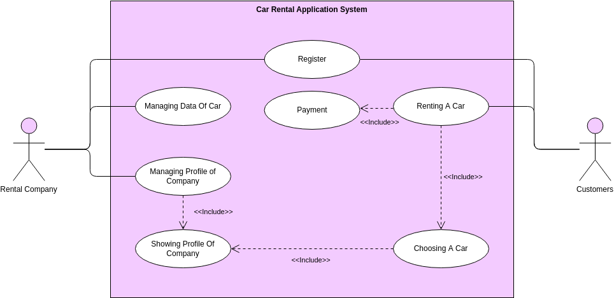

**2.6 E R Diagram**

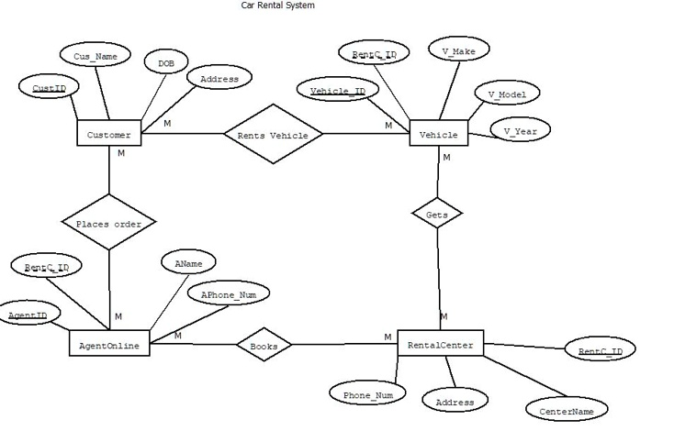

**2.7 SCOPE**

The scope of the Car Rental Project encompasses a wide range of functionalities and features designed to meet the diverse needs of users and administrators alike. Key components of the project include:

1. **User Registration and Authentication**: Users can create accounts, log in securely, and manage their profiles, ensuring personalized and secure access to the platform.
2. **Car Listings and Details**: The project features a comprehensive database of available cars, complete with detailed specifications, rental rates, and availability status.
3. **Reservation Management**: Users can browse through available cars, select their desired vehicle, and make reservations seamlessly through an intuitive booking system.
4. **Reservation Tracking**: Users have access to real-time updates on their reservations, allowing them to manage and track their rental bookings effortlessly.
5. **Administrative Tools**: Administrators have access to a suite of tools and functionalities to manage system settings, oversee inventory, and monitor rental transactions.

6**. Reporting and Analytics**: The project incorporates reporting and analytics features, enabling administrators to gain insights into system performance, user behavior, and revenue generation.

**2.8 Problem Statement**

Design and implement a Car Rental Management System that allows users to rent vehicles for a specified duration. The system should provide a user-friendly interface for both customers and administrators to manage the rental process efficiently.

**Problem Approach**:

Designing a car rental project requires a structured approach to ensure its success. Here's a general outline of how you can approach it:

1. **Define Requirements:**

• Understand the scope of the project: What features do you want to include? What type of car rentals will you offer (e.g., hourly, daily, luxury, budget)?

• Identify stakeholders: Who will use the system (customers, rental agents, administrators)?

1. **Market Research:**

• Analyze competitors: Look at existing car rental platforms to understand their features, pricing models, and user experience.

• Identify target audience: Determine the demographics and preferences of your potential users.

1. **System Design:**

• Choose the technology stack: Decide on the programming languages, frameworks, and databases to use.

• Architectural design: Design the system architecture, including components like user interface, database, backend services, and integrations.

• Database design: Define the database schema considering factors such as car details, user information, rental history, etc.

1. **Feature Prioritization**:

• Prioritize features based on their importance and feasibility. Essential features might include:

• User registration and authentication

• Search and filter functionality for cars

• Booking and payment processing

• Admin dashboard for managing cars, users, and rentals.

1. **Development:**

• Develop the system iteratively, starting with the core features and gradually adding more functionalities.

• Use version control systems (e.g., Git) to manage code changes and collaboration.

• Implement security best practices to protect user data and transactions.

1. **Testing:**

• Perform unit testing, integration testing, and system testing to ensure the reliability and functionality of the platform.

• Conduct usability testing to gather feedback on the user interface and overall user experience.

1. **Deployment:**

• Deploy the system to a staging environment for final testing.

• Once everything is working correctly, deploy it to a production environment.

• Monitor the system for any issues and be prepared to address them promptly.

8**. Marketing and Launch:**

• Develop a marketing strategy to attract customers to the platform.

• Offer promotions or discounts to incentivize users to try the service.

•Launch the platform and monitor its performance closely.

**9.Maintenance and Support:**

• Provide ongoing maintenance to fix bugs, optimize performance, and update features.

• Offer customer support to assist users with any issues they encounter.

• Gather feedback from users to continuously improve the platform.

**10.Scaling:**

• As the user base grows, scale the infrastructure to handle increased traffic and data volume.

• Continuously evaluate and improve the system's scalability and performance.

**2.9 SNAPSHOTS**

**Home Page**

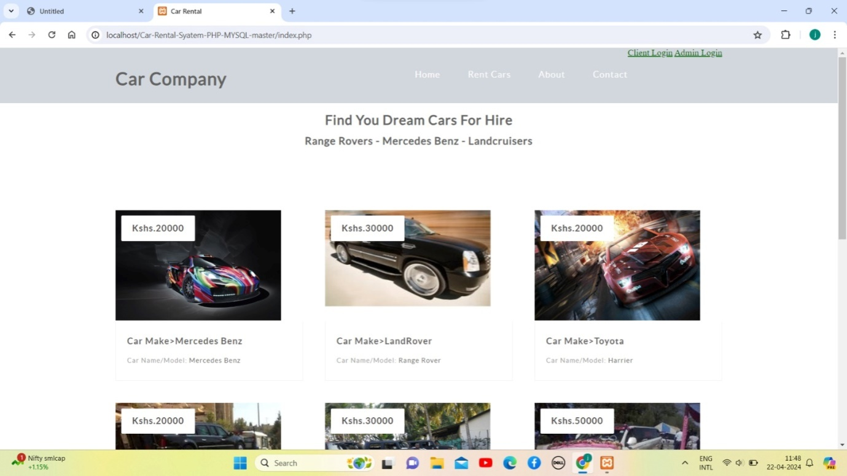

**Admin Login**

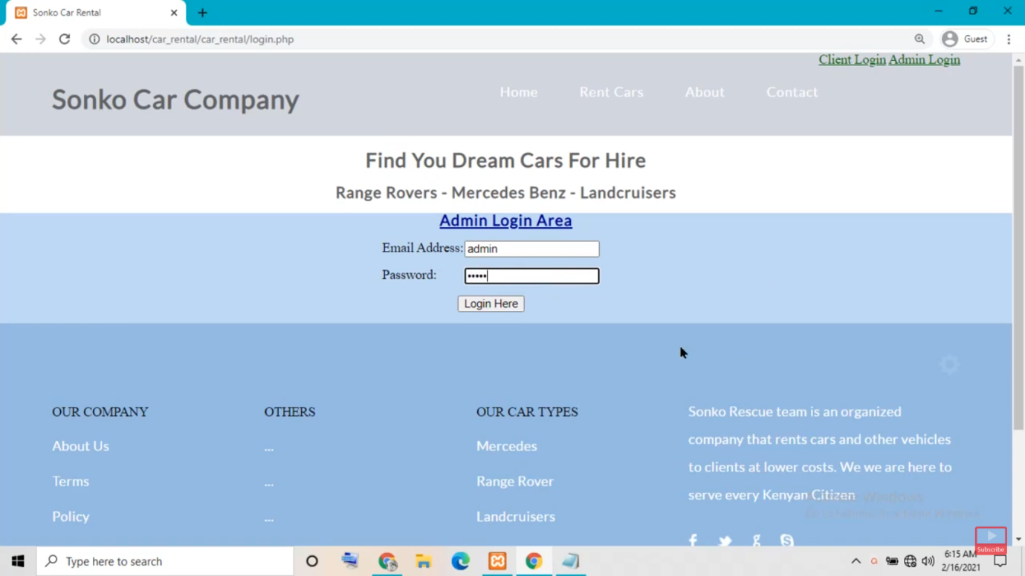

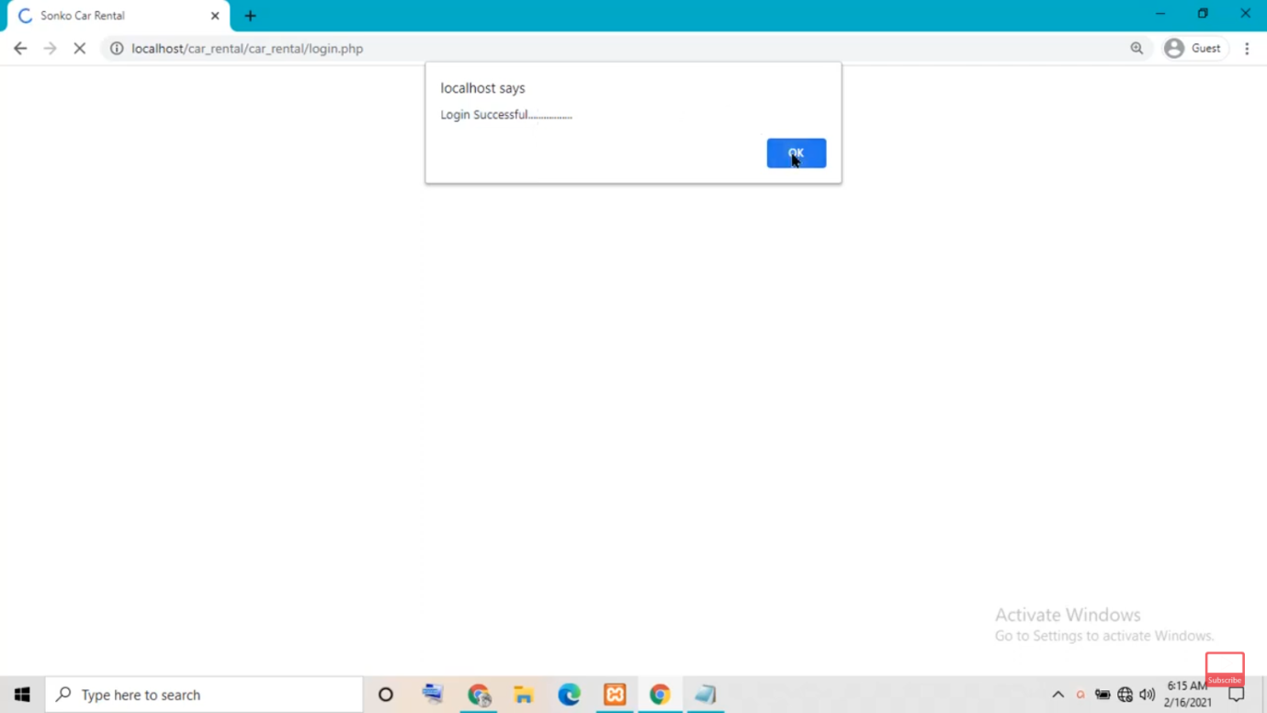

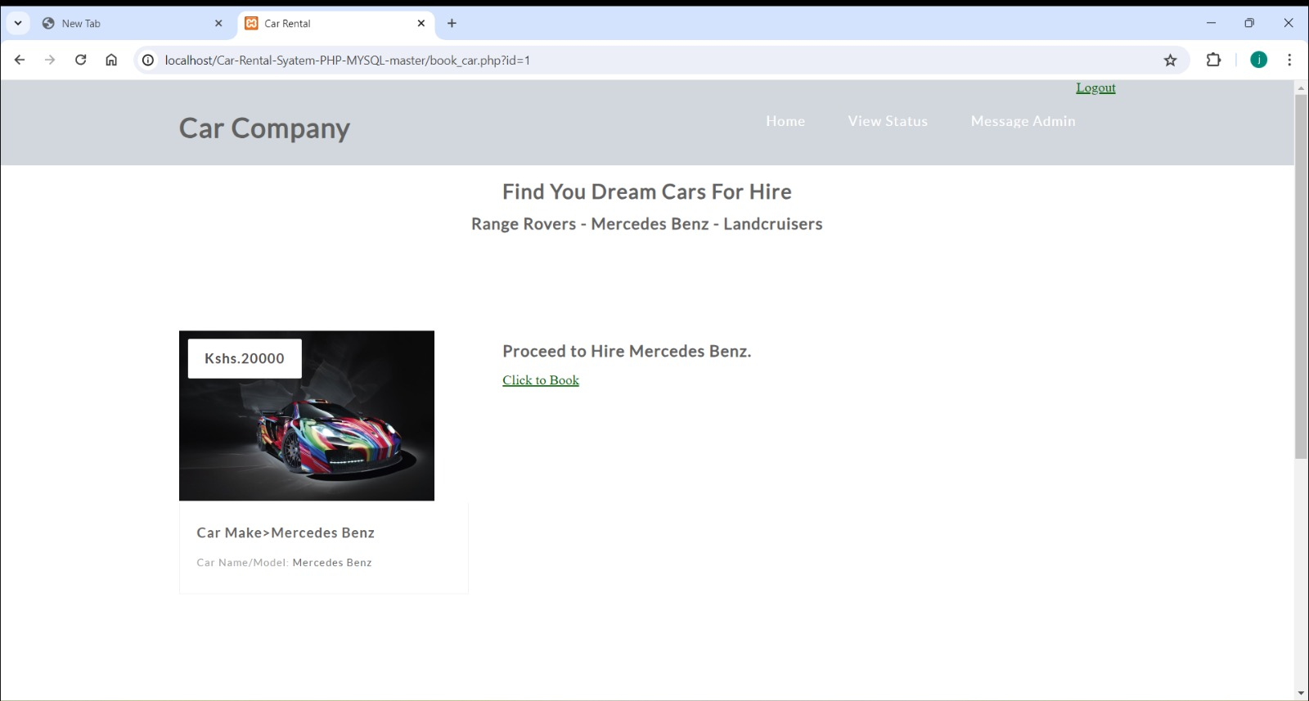

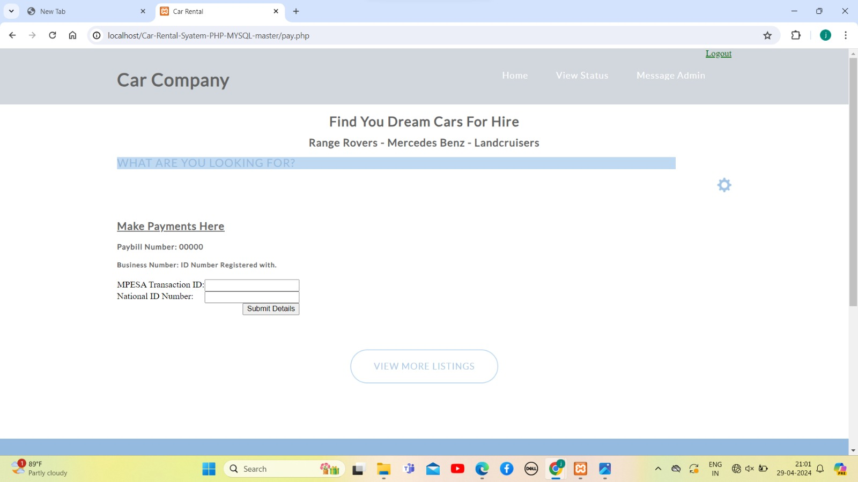

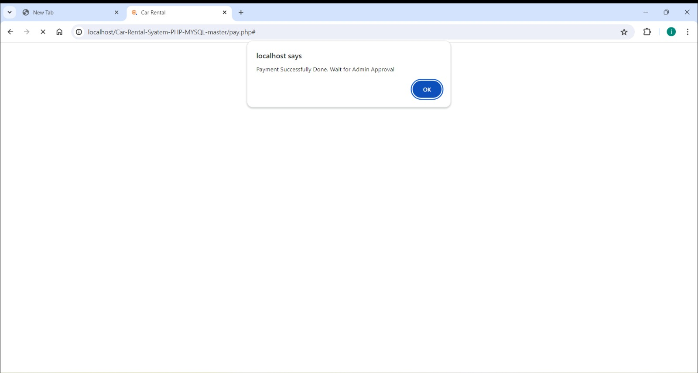

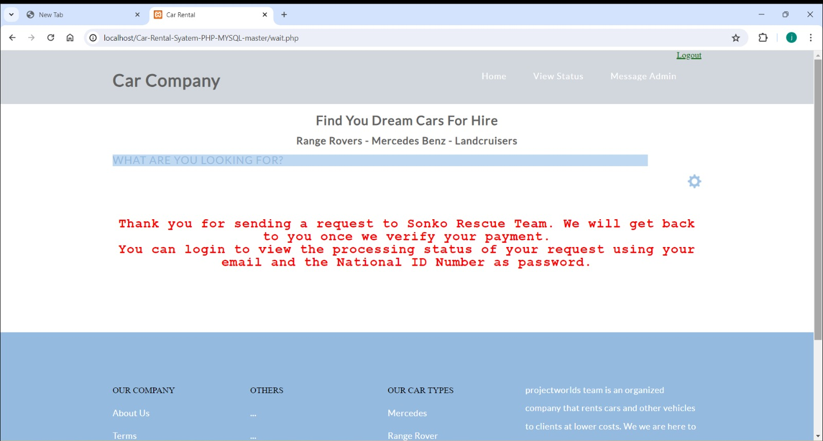

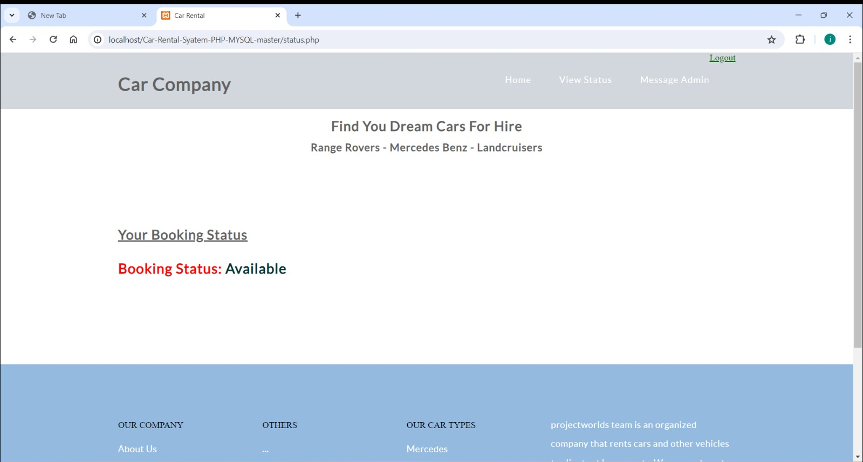

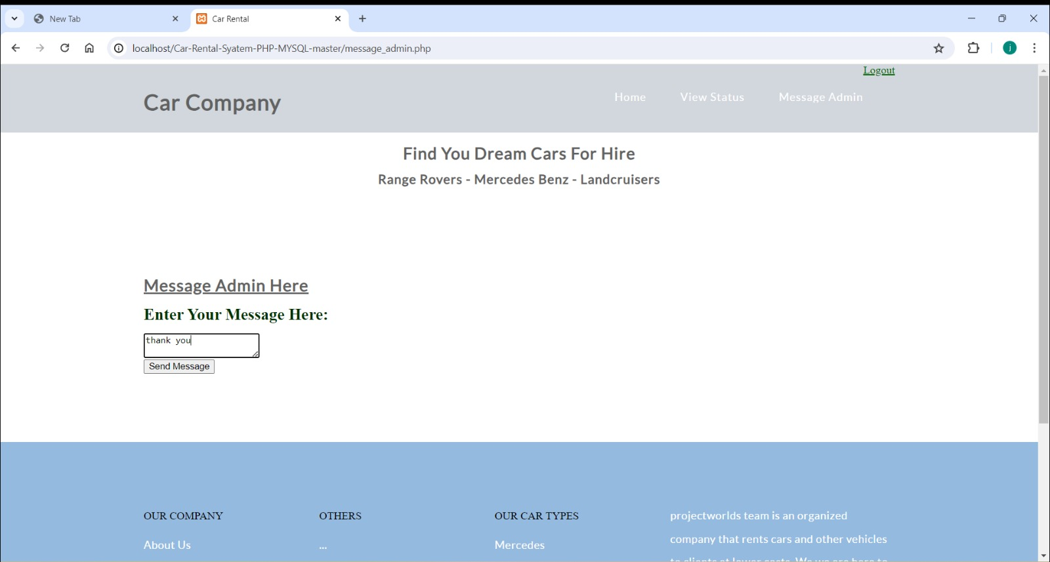

**Admin Dashboard**

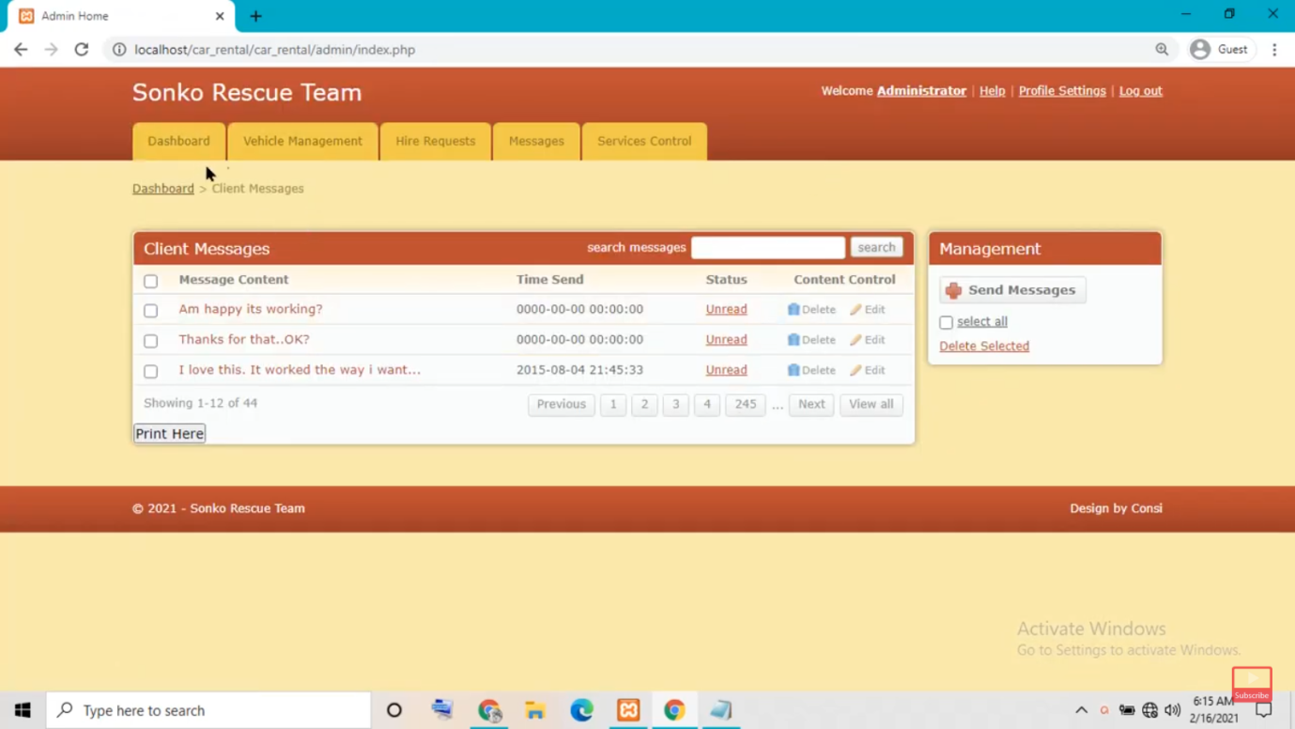

**Database**

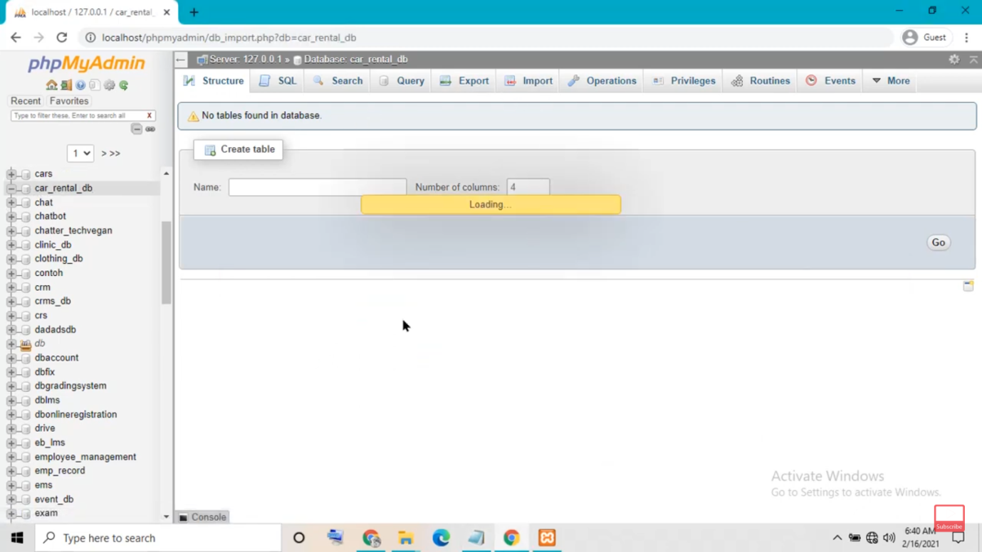

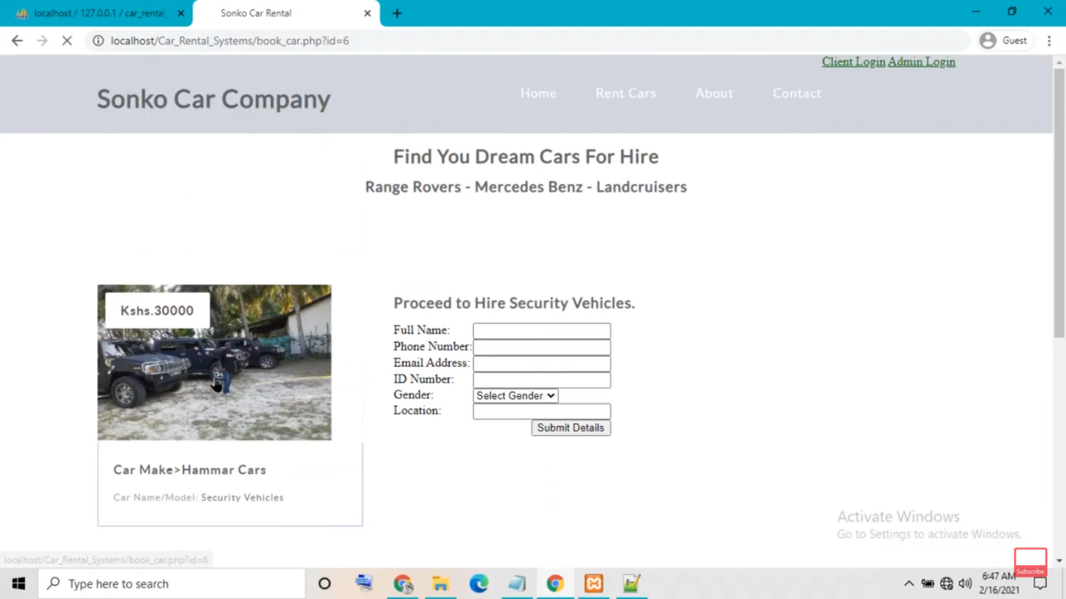

**2.10 Results**

The success of a car rental project can be measured by various key performance indicators (KPIs) and outcomes. Here are some typical results you might expect from a car rental project:

1. **User Engagement Metrics:**

•Number of registered users: Indicates the size of your user base.

•Active users: The percentage of registered users who actively use the platform within a given time frame.

•Repeat bookings: Percentage of users who book a car multiple times, indicating satisfaction and loyalty.

1. **Booking Metrics**:

•Total bookings: Number of car rentals completed through the platform.

•Booking frequency: Average number of bookings per user or per day.

•Booking conversion rate: Percentage of website visitors who make a booking.

1. **Revenue Generation:**

•Total revenue: The sum of all rental fees collected.

•Average revenue per booking: Total revenue divided by the number of bookings.

•Growth in revenue over time: Month-over-month or year-over-year increase in revenue.

1. **Customer Satisfaction:**

Customer ratings and reviews: Feedback from users about their experience with the platform and rental process.

•Net Promoter Score (NPS): Measures the likelihood of users to recommend the service to others.

1. **Operational Efficiency:**

•Utilization rate: Percentage of time that cars are rented out versus sitting idle.

•Average turnaround time: Time taken to prepare a car for the next rental after it is returned.

•Maintenance costs: Costs associated with servicing and maintaining the fleet of rental cars.

1. **Market Penetration:**

•Market share: Percentage of the total market for car rentals that your platform captures.

•Competitor analysis: Comparison of your platform's performance with that of competitors in terms of market share and growth.

1. **Fraud and Security:**

•Fraudulent activities: Number of fraudulent transactions detected and prevented.

•Security incidents: Number of security breaches or incidents reported and addressed.

1. **Technical Metrics:**

•Uptime: Percentage of time the platform is operational and accessible to users.

•Page load time: Speed at which web pages load, affecting user experience and retention.

1. **Regulatory Compliance**:

•Adherence to legal and regulatory requirements related to car rental services, such as insurance, licensing, and data protection laws

.

1. **Feedback and Iteration**:

•Use of user feedback to drive continuous improvement and iteration of the platform.

•Implementation of new features and enhancements based on user needs and market trends.

**2.11 References**

When seeking references for a car rental project, you'll want to consult a variety of sources to gather insights and best practices. Here are some references you might find helpful:

1. **Industry Reports and Studies:**

•Reports from market research firms such as IBISWorld, Statista, and MarketResearch.com can provide valuable insights into the car rental industry, including market trends, key players, and growth forecasts.

1. **Academic Journals and Publications:**

•Scholarly articles and papers on topics related to car rental systems, transportation management, and rental industry dynamics can offer in-depth analysis and research findings.

1. **Books:**

•Books on rental business management, customer service, and digital platforms can provide practical advice and strategies for building and running a successful car rental project.

1. **Online Articles and Blogs:**

•Websites like Forbes, Entrepreneur, and Harvard Business Review often publish articles on business strategy, technology innovation, and industry trends that may be relevant to your project.

1. **Case Studies:**

•Case studies from car rental companies or similar businesses can offer real-world examples of challenges faced, strategies employed, and outcomes achieved in the industry.

1. **Online Forums and Communities:**

•Participating in online forums such as Reddit's r/Entrepreneur or industry-specific communities on platforms like LinkedIn can provide opportunities to connect with professionals in the car rental or tech startup space and learn from their experiences.

1. **Consulting Firms and Expert Advisors:**

•Consulting firms specializing in transportation, logistics, or technology may offer consulting services or white papers that provide insights and recommendations for launching and operating a car rental project.

1. **Government Publications and Regulations:**

•Government websites and publications may contain information on regulations, licensing requirements, and industry standards relevant to the car rental business in your jurisdiction.

1. **Vendor Documentation and Case Studies:**

•If you're considering using specific software or technology solutions for your project, vendor documentation, case studies, and user testimonials can help you understand how their products have been used in similar contexts.

1. **Networking and Interviews:**

•Networking with industry professionals, attending conferences or webinars, and conducting interviews with experts can provide firsthand knowledge and insights specific to the car rental industry.

By consulting these references, you can gain a comprehensive understanding of the car rental business landscape and gather valuable insights to inform your project's strategy and execution.

**2.12 Conclusion**

The Car Rental Project represents a significant milestone in the realm of online car rental services. By amalgamating state-of-the-art technologies with user-centric design principles, it delivers a seamless and intuitive platform for users to rent cars hassle-free. With continuous enhancements and future iterations, the project is poised to redefine the car rental experience, setting new standards for convenience, efficiency, and customer satisfaction.

This report encapsulates the essence of the Car Rental Project, shedding light on its architecture, functionalities, and technologies, while highlighting its potential to revolutionize the car rental industry.

**CHAPTER-3**

**3.1 Abstract**

In the digital age, where first impressions are often made online, the significance of a well-crafted resume cannot be overstated. Recognizing this need, our project endeavors to develop a cutting-edge Resume Builder Website, aimed at simplifying and enhancing the resume creation process for job seekers worldwide.

This project aims to address several key challenges faced by job seekers when crafting resumes. These challenges include time-consuming formatting, difficulty in tailoring resumes to specific job requirements, and limited access to professional design tools. By offering a user-friendly platform with customizable templates and intuitive design features, our website seeks to empower users to create polished resumes efficiently.

The Resume Builder Website will feature a user-friendly interface, allowing users to easily input their personal and professional information. Through an interactive step-by-step process, users will be guided in selecting appropriate templates and customizing layout, fonts, and colors to suit their preferences. Additionally, the website will provide suggestions for relevant skills, experiences, and keywords based on the user's industry and job level, helping to optimize their resume content.

One of the innovative features of our project is the integration of Artificial Intelligence (AI) technology to enhance the resume creation process. Through Natural Language Processing (NLP) algorithms, the website will analyze job descriptions and provide personalized recommendations to users on how to tailor their resumes for specific positions. This functionality will enable users to increase their chances of success by aligning their resumes with the requirements of prospective employers.

**3.2** **Introduction**

In an era where digital interfaces have become the primary means of communication and interaction, the importance of a well-crafted resume cannot be overstated. A resume serves as the cornerstone of one's professional identity, acting as a vital tool for job seekers to showcase their skills, experiences, and qualifications to potential employers. However, the process of creating a compelling resume is often fraught with challenges, ranging from formatting complexities to the daunting task of tailoring content to specific job requirements.

Recognizing these challenges and the growing demand for streamlined solutions in the job search process, we are excited to introduce our innovative Resume Builder platform. Our platform represents a transformative approach to resume creation, harnessing the power of technology to simplify the process and empower users to present themselves effectively in today's competitive job market.

At its core, our Resume Builder platform is designed to democratize access to professional resume-building tools, making them accessible to job seekers of all backgrounds and skill levels. Whether you're a recent graduate entering the workforce or a seasoned professional seeking new opportunities, our platform offers a user-friendly interface and robust features to meet your needs.

The significance of a well-designed resume extends beyond mere aesthetics; it is a reflection of one's professional identity and potential. With this understanding, our platform prioritizes not only ease of use but also the creation of visually appealing and impactful resumes. Users will have access to a diverse range of professionally designed templates, each meticulously crafted to convey competence, professionalism, and personality.

**3.3 Objectives**

**1. Project Development:**

Apply expertise in front-end and back-end technologies to develop innovative and functional projects.

Collaborate with cross-functional teams to translate project requirements into actionable development tasks.

Ensure adherence to project timelines and deliver high-quality solutions that meet or exceed client expectations.

**2. Technical Proficiency:**

Expand knowledge and skills in front-end technologies such as HTML5, CSS3, JavaScript, and popular frameworks like React.js or Angular.js.

Enhance proficiency in back-end technologies including server-side scripting languages like Node.js, Python, or PHP, and databases like MySQL or MongoDB.

Stay updated on emerging trends and best practices in web development to continuously improve technical expertise.

**3. User Experience Enhancement:**

Focus on creating user-centric designs and seamless user experiences through intuitive front-end interfaces.

Implement responsive design principles to ensure optimal performance across various devices and screen sizes.

Leverage user feedback and usability testing to iterate and refine project features for improved usability and satisfaction.

**4. Problem Solving and Innovation:**

Demonstrate strong problem-solving skills to overcome technical challenges and optimize project performance.

Foster a culture of innovation by exploring new technologies and methodologies to enhance project functionalities and efficiency.

Drive continuous improvement initiatives to streamline development processes and maximize productivity.

**5. Team Collaboration and Communication:**

Foster a collaborative work environment by effectively communicating with team members and stakeholders to align on project goals and priorities.

Contribute to cross-functional teams with a positive attitude, sharing insights and best practices to support collective success.

Actively participate in code reviews, brainstorming sessions, and knowledge-sharing activities to foster a culture of learning and growth.

**6. Career Advancement:**

Seek opportunities for professional growth and advancement within the field of web development.

Pursue certifications, training programs, and educational opportunities to further enhance skills and expertise.

Aspire to contribute to impactful projects and make a positive difference in the digital landscape through continuous learning and development.

These objectives provide a clear overview of your aspirations and goals in the context of building projects, highlighting your focus on technical proficiency, user experience enhancement, problem-solving, teamwork, and career advancement. Adjust the details as per your specific career objectives and aspirations.

**3.4 Methodology**

**Front-End Technologies**

**1. Requirement Analysis**

Conduct thorough analysis of project requirements and objectives.

Identify front-end and back-end technology needs based on project specifications.

**2. Technology Selection:**

Evaluate various front-end technologies such as HTML5, CSS3, JavaScript, and frameworks like React.js or Angular.js.

Assess back-end technologies including server-side scripting languages like Node.js, Python, or PHP, and databases like MySQL or MongoDB.

Select optimal technologies based on project scalability, performance, and client requirements.

**3. Front-End Development:**

Utilize chosen front-end technologies to create intuitive user interfaces and engaging user experiences.

Implement responsive design principles to ensure compatibility across multiple devices and screen sizes.

Collaborate with UI/UX designers to translate design mockups into functional front-end components.

**Back-End Technologies**

**4. Back-End Development:**

Develop robust server-side logic using selected back-end technologies to handle data processing and storage.

Design and implement RESTful APIs for seamless communication between front-end and back-end systems.

Implement authentication and authorization mechanisms to ensure data security and user privacy.

**5. Integration and Testing:**

Integrate front-end and back-end components to create a cohesive and fully functional application.

Conduct thorough testing of both front-end and back-end functionalities to identify and address any issues or bugs.

Perform cross-browser and cross-platform testing to ensure compatibility and consistent performance.

**6. Optimization and Performance Tuning:**

Optimize front-end code for faster loading times and improved user experience.

Fine-tune back-end code to enhance application performance and scalability.

**3.5 FUNCTIONAL REQUIREMENTS**

**Use Case Diagram**

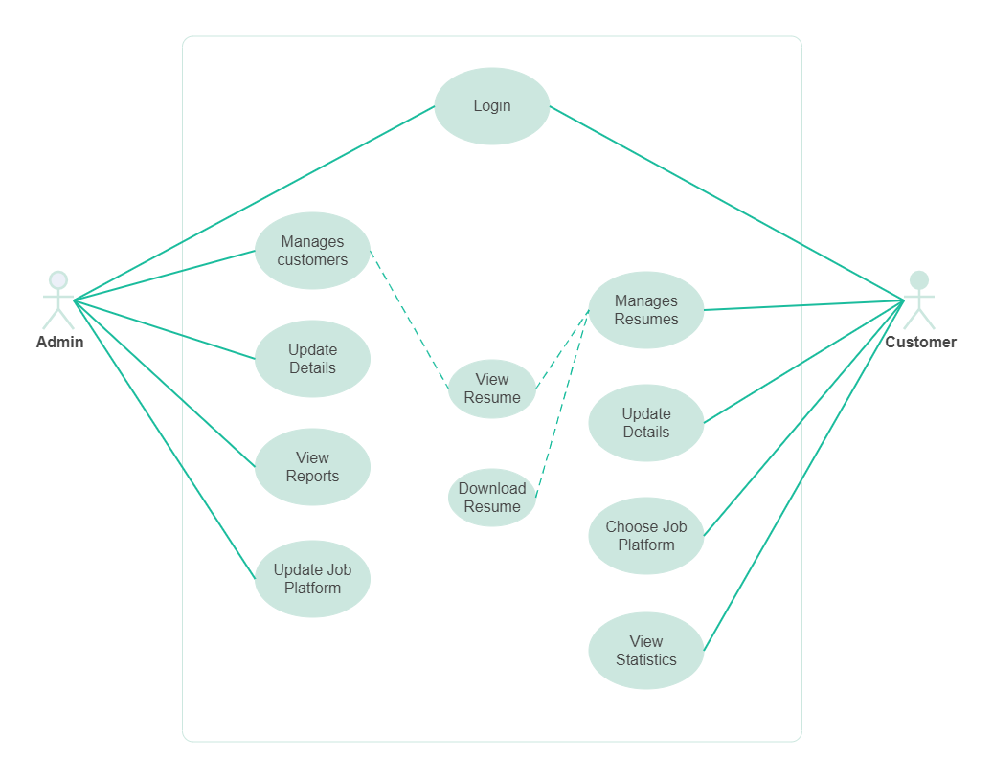

**3.6** **ER Diagram**

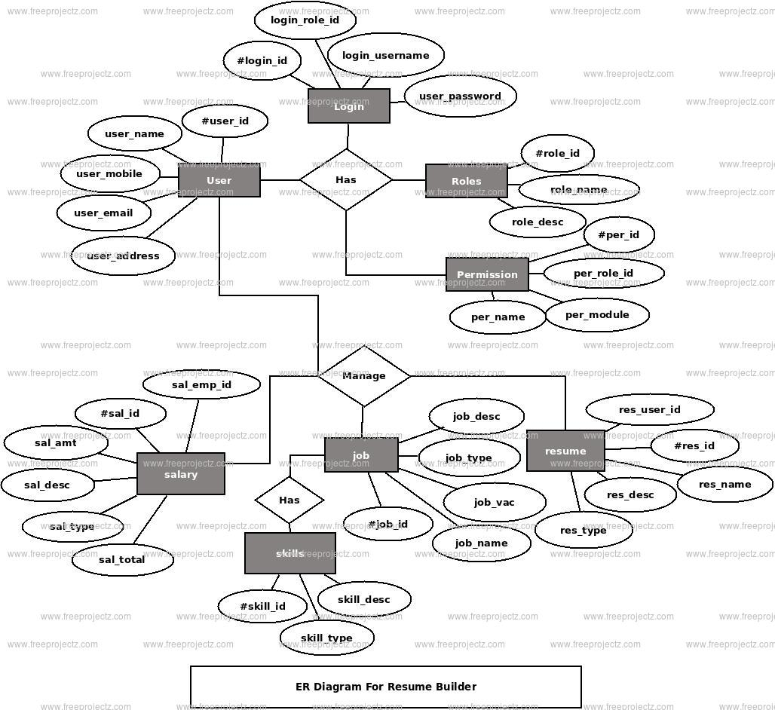

**3.7 Scope**

**1. Platform Overview:**

The project aims to develop a user-friendly online platform for creating and managing professional resumes.

**2. User Features:**

Users can register and create personal profiles.

Users can input and manage various resume sections such as education, work experience, skills, certifications, and projects.

Users can customize the layout, formatting, and order of resume sections.

Users can choose from a selection of professionally designed resume templates.

Users can import data from LinkedIn or other platforms to populate their resume automatically.

Users can collaborate with others and share their resume drafts for feedback.

**3. Resume Creation Process:**

Users can add, edit, and delete content within each resume section.

Users can input their skills and proficiency levels, with the option for the system to suggest relevant skills.

Users can preview their resume in real-time and make adjustments as needed.

Users can export their completed resume in various file formats such as PDF, Word, or HTML.

**4. Technical Requirements:**

The platform will be built using modern web development technologies such as HTML5, CSS3, JavaScript, and a backend framework like Node.js or Django.

The platform will be mobile-responsive, ensuring a seamless user experience across different devices.

Robust data encryption and security measures will be implemented to protect users' personal information.

**5. Project Constraints:**

The project will have a defined timeline and budget for development.

The platform will initially target a specific audience or industry segment.

Certain advanced features such as machine learning-based resume optimization may be considered for future iterations based on resource availability and user feedback.

**6. Deliverables:**

The final deliverable will be a fully functional web-based resume-building platform deployed to a production environment.

Documentation will be provided for system architecture, user guide, and maintenance instructions.

**7. Exclusions**:

The project will not include job search functionalities or job application management.

The platform will not provide career coaching or resume writing services beyond basic guidance and templates.

**8. Assumptions:**

It is assumed that users have basic computer literacy and internet access.

Users are responsible for the accuracy and completeness of the information they input into their resumes.

**9. Risks:**

Risks include potential technical challenges during development, data security breaches, and user adoption issues.

Mitigation strategies will be implemented to address identified risks throughout the project lifecycle.

**10. Stakeholders:**

Stakeholders include project sponsors, developers, users, and potentially third-party integrators (e.g., LinkedIn API).

**3.8 Problem Definition**

**1. Complexity and Time-Consuming Process:**

Many individuals find the process of creating or updating a resume to be daunting and time-consuming.

Formatting issues, content organization, and design choices often lead to frustration and inefficiency.

**2. Lack of Guidance and Resources**:

Individuals may struggle to know what information to include in their resumes and how to present it effectively.

Limited access to professional templates, guidance on industry best practices, and feedback on draft resumes further exacerbate the challenge.

**3. Inconsistent Presentation and Quality:**

Without standardized templates or guidelines, resumes often vary widely in terms of design aesthetics, content quality, and overall presentation.

Inconsistencies in formatting and content may hinder recruiters' ability to quickly assess candidates' qualifications.

**4. Compatibility and Accessibility Issues:**

Traditional resume-building methods such as using word processors or templates may not always produce resumes that are compatible across different devices or software platforms.

Lack of mobile responsiveness and accessibility features can limit users' ability to create and share resumes effectively.

**5. Difficulty in Tailoring Resumes for Different Roles:**

Crafting customized resumes tailored to specific job opportunities requires careful consideration of relevant skills, experiences, and keywords.

Without guidance or tools to streamline this process, individuals may struggle to adapt their resumes for different roles or industries.

**6. Security and Privacy Concerns:**

Sharing personal and professional information on resumes raises concerns about data privacy and security.

Users may hesitate to input sensitive information into online resume-building platforms without assurance of robust data protection measures.

**7. Need for Continuous Updates and Maintenance:**

Resumes are dynamic documents that require regular updates to reflect new experiences, skills, or qualifications.

Lack of efficient tools for managing resume updates may result in outdated or incomplete resumes.

**8. Accessibility for Diverse Audiences:**

Ensuring accessibility for individuals with disabilities, including visual impairments or mobility limitations, is essential for creating inclusive resume-building solutions.

**9. Career Advancement Implications**:

Ineffective resume creation and presentation may negatively impact individuals' ability to secure employment opportunities and advance in their careers.

Addressing resume-building challenges directly contributes to individuals' professional success and opportunities for growth.

This problem definition highlights the key pain points and challenges that individuals face when creating or updating their resumes, providing a foundation for developing effective solutions to address these needs. Adjustments can be made based on specific user demographics, industry trends, and project objectives.

**3.9 SNAP SHOTS**

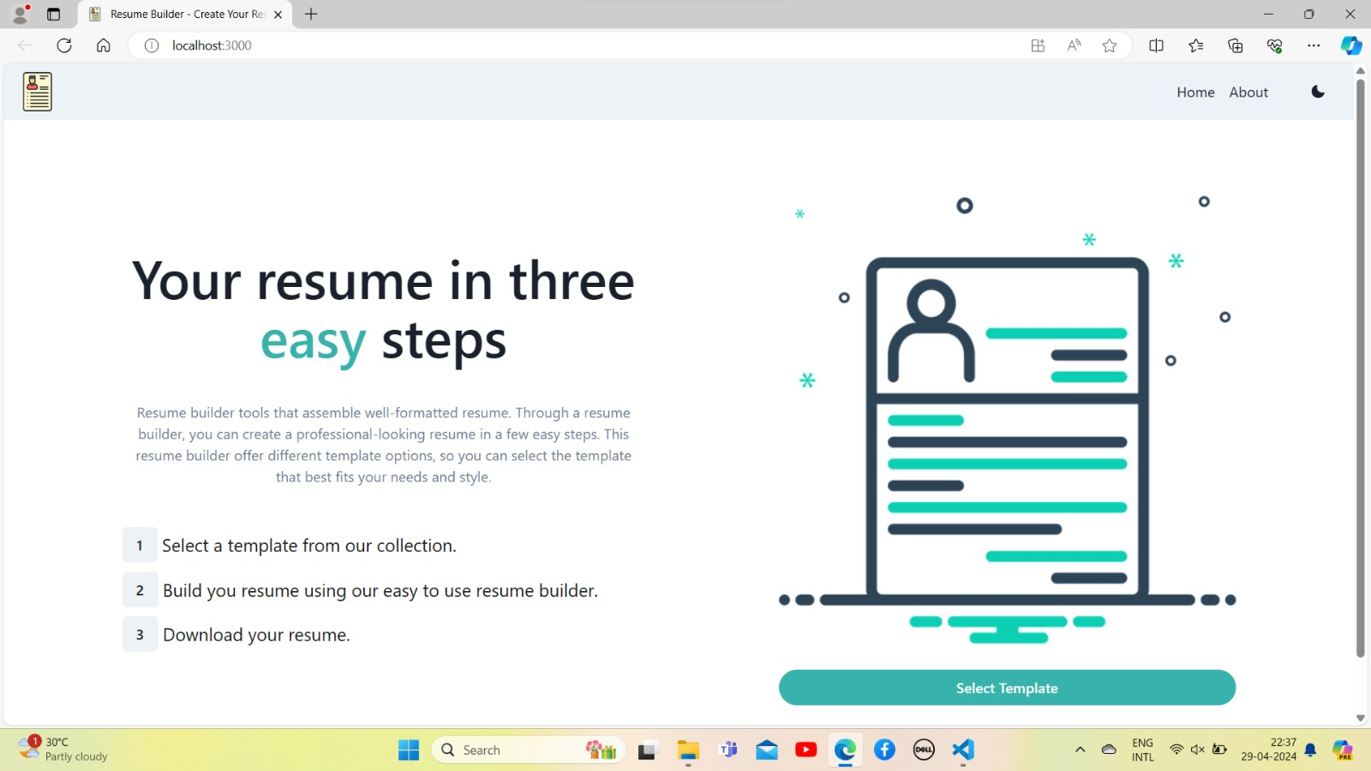

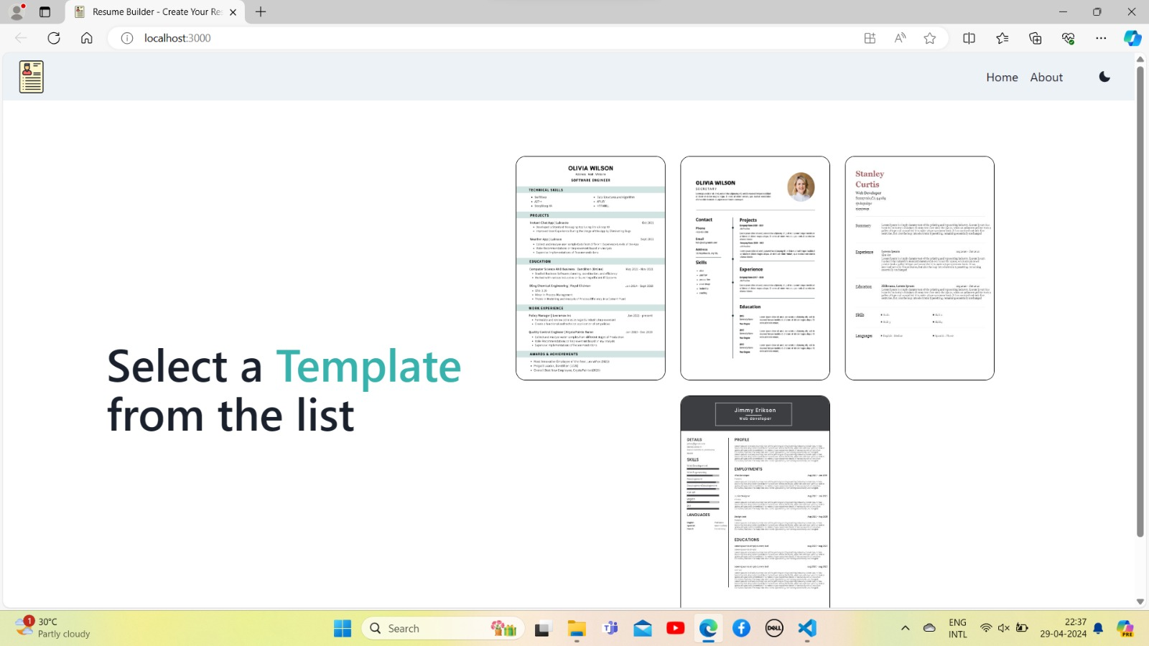

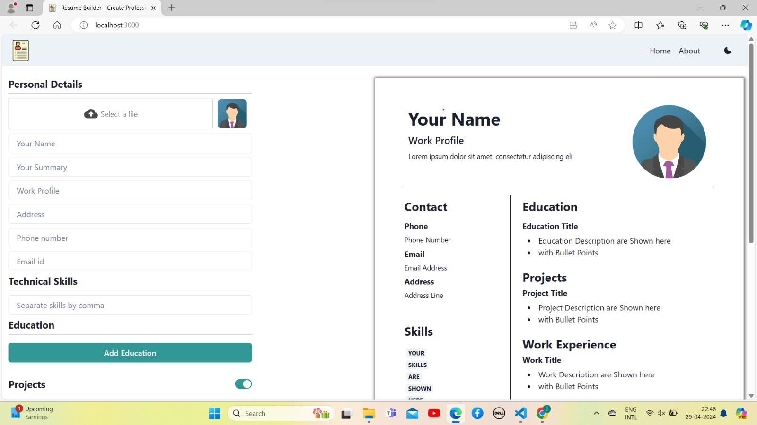

**3.10 Results**

1. **Clarity and Readability:**

Ensure your resume is easy to read and understand at a glance. Use clear headings, bullet points, and concise language to convey your skills and experiences.

Relevance: Tailor your resume to the specific job you're applying for. Highlight experiences, skills, and accomplishments that are most relevant to the position.

1. **Achievements:**

Instead of just listing job responsibilities, focus on your accomplishments and contributions in each role. Use quantifiable metrics whenever possible to demonstrate the impact you've made.

1. **Keywords:**

Incorporate relevant keywords from the job description into your resume. Many employers use Applicant Tracking Systems (ATS) to scan resumes for specific keywords, so including them can increase your chances of getting noticed.

1. **Professionalism:**

Make sure your resume presents you in a professional light. Use a clean, professional format and avoid including personal information that's not relevant to the job.

1. **Customization:**

Customize each resume for the job you're applying for. This might involve rearranging sections, emphasizing different skills or experiences, or even creating multiple versions of your resume for different types of roles.

1. **Proofreading:**

Thoroughly proofread your resume to ensure it's free of typos, grammatical errors, and formatting issues. You might even consider asking a friend or mentor to review it for you.

1. **Consistency**:

Maintain consistency in formatting, style, and terminology throughout your resume. This helps to create a cohesive and professional document.

1. **Visibility:**

Make sure your resume is easy to find by uploading it to online job boards, professional networking sites, and your personal website (if you have one).

1. **Continual Improvement:**

Finally, view your resume as a work in progress and be open to continually updating and improving it as your skills and experiences evolve.

By focusing on these results, you can create a resume that effectively showcases your qualifications and helps you stand out to potential employers.

**3.11 References**

When building a resume, it's important to consider including references or at least having them prepared for when potential employers request them. Here are some key points to keep in mind regarding references:

1. **Include a References Section:**

In most cases, it's not necessary to include references directly on your resume. Instead, create a separate section titled "References" that you can provide upon request.

1. **Choose Your References Wisely:**

Select references who can speak positively about your work ethic, skills, and character. Ideally, these should be individuals who have supervised or worked closely with you in a professional capacity. Examples include former managers, supervisors, colleagues, professors, or mentors.

1. **Ask for Permission:**

Before listing someone as a reference, always ask for their permission first. This allows them to prepare and ensures they're comfortable providing a reference for you.

1. **Provide Relevant Information:**

When asking someone to be a reference, provide them with relevant information about the job you're applying for and why you believe they would be a good reference. This can help them tailor their comments to the position.

1. **Keep Your References Informed:**

If you're actively job hunting and using references, keep them informed about the jobs you're applying for and any developments in your job search. This allows them to be prepared if they receive a call or email from a potential employer.

1. **Format for Reference List:**

When creating your reference list, include each reference's name, job title, company, contact information (phone number and email address), and a brief description of your relationship with them. Arrange the list in alphabetical order by last name.

1. **Consider Diversity:**

Try to include a diverse range of references that represent different aspects of your professional life, such as different jobs, industries, or educational experiences.

1. **Keep References Updated:**

Periodically check in with your references to ensure their contact information and availability are up-to-date. If someone on your reference list changes jobs or contact information, be sure to update your reference list accordingly.

1. **Be Grateful:**

After using someone as a reference, whether you get the job or not, take the time to thank them for their support and assistance. Showing gratitude reinforces your professional relationships.

.

**3.12 Conclusion**

In conclusion, building a resume is a strategic process aimed at showcasing your qualifications, experiences, and achievements to potential employers. By focusing on clarity, relevance, professionalism, and customization, you can create a resume that effectively highlights your strengths and makes a positive impression. Remember to tailor your resume to each job application, include relevant keywords, and emphasize your accomplishments rather than just listing job duties. Additionally, consider the importance of references and how to manage them effectively, ensuring you have a list of credible individuals who can speak to your abilities and character. Continuously updating and improving your resume, seeking feedback, and staying organized throughout the job application process will help you present yourself as a strong candidate and increase your chances of landing interviews and securing employment opportunities.